Choose the book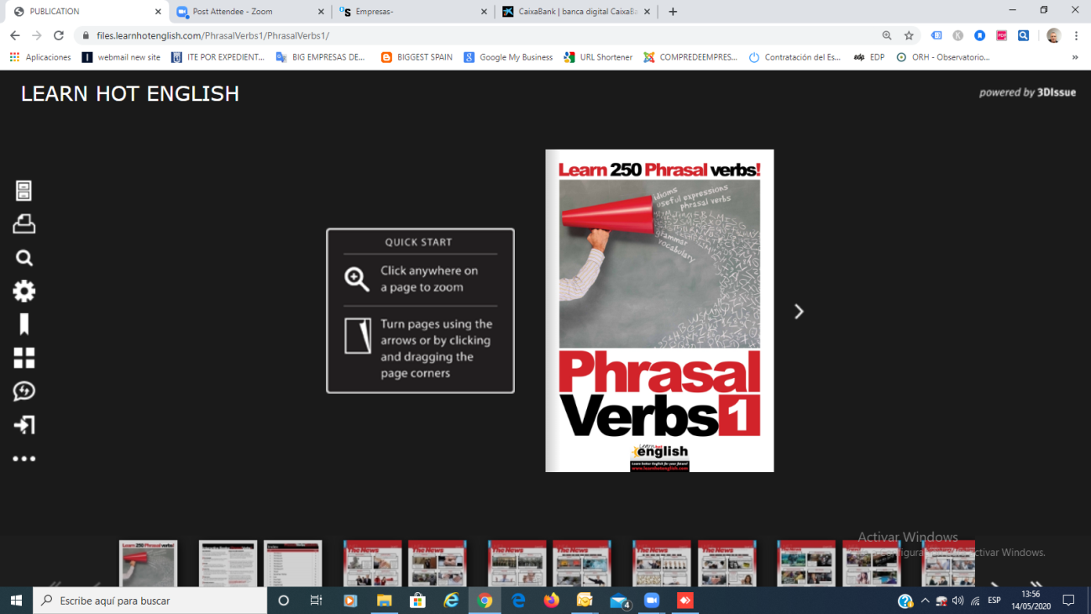

Choose from the sidebar the print option
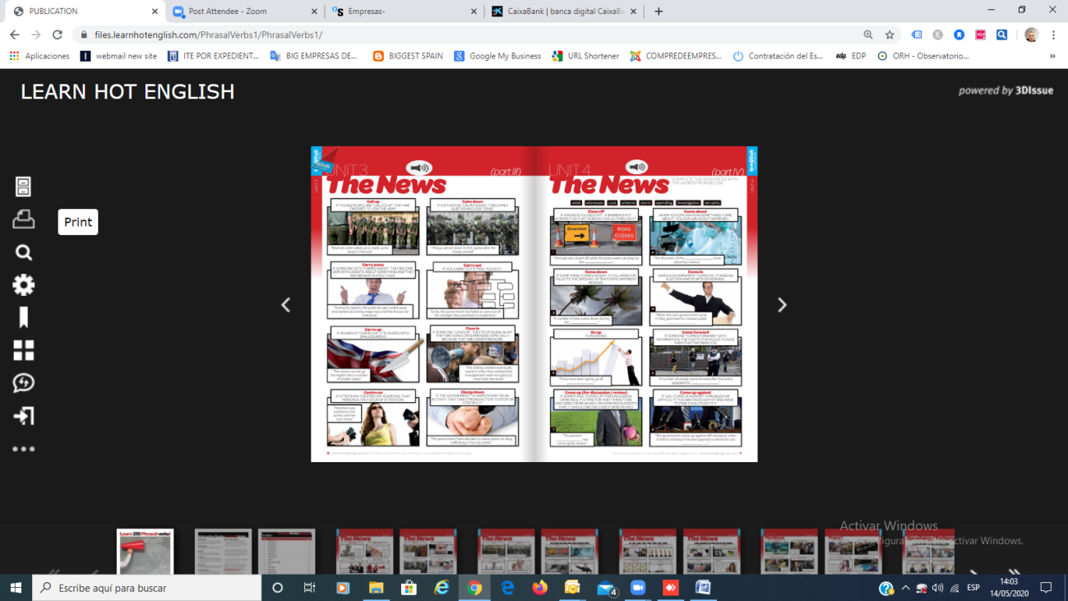

Choose the pages you wish to save as pdf

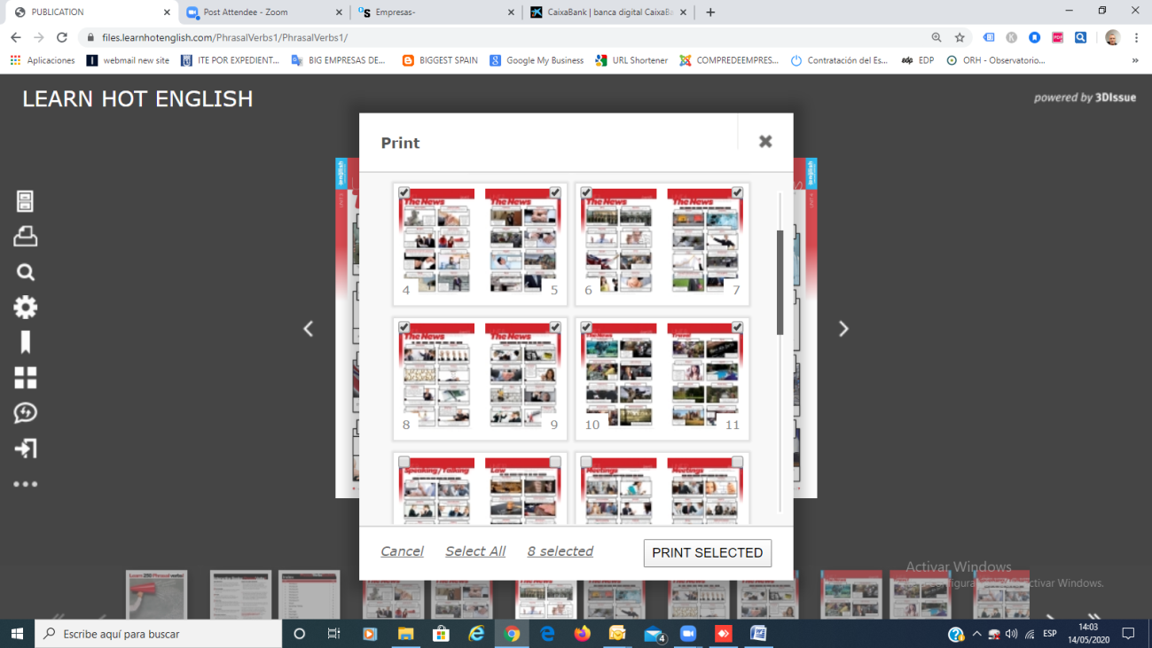
Choose GUARDAR COMO PDF / SAVE AS A PDF
CHOOSE VERTICAL AS THE DISEÑO/DESIGN OPTION (not horizontal)
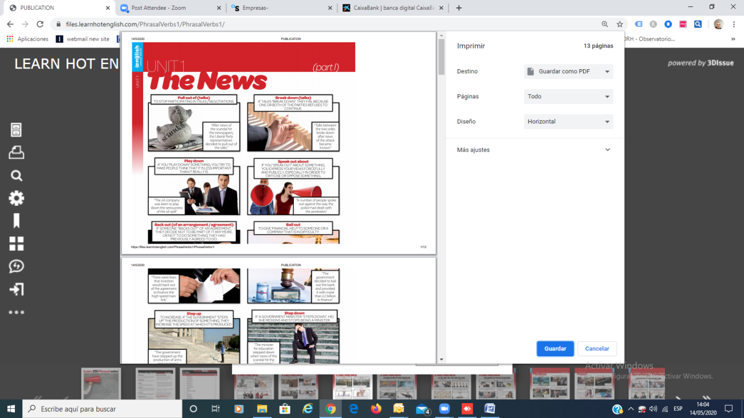
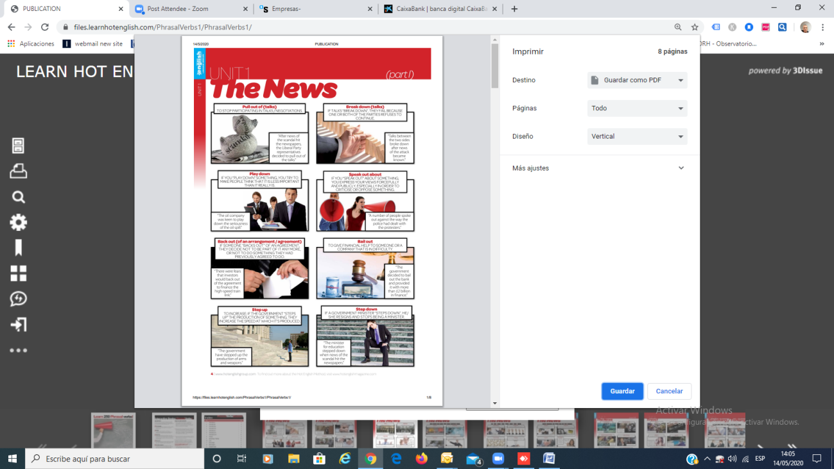
THEN PRESS BLUE BUTTON GUARDAR /SAVE

